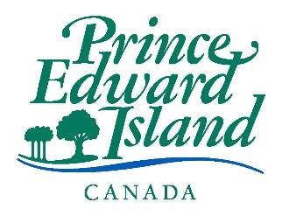
PEI Arts Grants
Project Description Template
If you are applying to the PEI Arts Grants program, we encourage you to use this template to include a detailed project description with your application.
All questions are mandatory and should be answered. Only answer questions 6 and 7 if you are applying to the Create (Creation) and Share (Dissemination) streams of the PEI Arts Grants program.
Question 1: What is the artistic vision of the proposed project?
Question 2: How does the project demonstrate growth from previous artistic achievements?
Question 3: How will the project contribute to your ongoing goals and development?
Question 4: How will you complete the project, i.e. what are the project plans and timelines?
Question 5: How will the project impact your career development/arts practice?
Question 6: What will you produce? (Create and Share streams only)
Question 7: How do you plan on presenting or sharing the completed work? Please describe. (Create and Share streams only)

